William Mackay
MTH 337, Professor Adam Cunningham

Weekly Report 03
Introduction
The populations of many animal species can be modeled as deterministic dynamical systems, or systems that undergo some sort of process and whose state at any given time is dependent upon the previous state only. Mayflies, because they tend to mature in large numbers together and then die off quickly every year, are good subjects for this sort of model. Their short lifespan reduces the complexity of the model because none of the population carries over from year to year. As a result, the mayfly population each year can be assumed to be dependent only upon the previous year's population and the maximum growth rate (which is dependent upon several factors, including resources, survival rates, etc.) and can therefore be represented as a deterministic dynamical system. For this assignment, a model for yearly changes in a mayfly population was developed and implemented in Python. The response of the model was then tested and analyzed for many different growth rates.
Approach
In order to develop the mayfly population model, several assumptions were made that simplified the final model. First, it was assumed that half of the mayfly population was female and that all female mayflies laid eggs. Second, it was assumed that the growth rate was indirectly proportional to the population or, in other words, fewer offspring survived when the population was high. Because the system is assumed to be deterministic, the population one year (n_{t}) is dependent upon the population of the previous year (n_{t+1}) and some factor a that determines growth rate (a) based on surviving offspring. The early model, therefore, was of the form , where 'a' was unknown and depended on assumptions about the growth rate. Because of the assumption that growth rate decreases with population, 'a' was assumed to be of the form, where 'k' is the maximum supported population. When this was substituted into the model, it became. This was further simplified by defining 'x_{t}' as 'n_{t}/k' and 'a₀/2' as 'b'. The final model was. Here, 'b' represented the growth rate and 'x_{t}' represented the ratio between the current population and the maximum supported population.
Once the model was developed, it was fairly simple to implement it in Python using array vectorization and a for-loop. The model was then tested with different b values to see how changes in growth rate affected the model response. First, the transient response, or the portion of the population plot that is time variant, was tested and plotted for b values ranging from 0 to 3. This was done by constructing a function that ran and plotted the model for some initial population, growth rate, and time and calling the function for several 'b' values. Only the first 25 years were simulated during each loop to ensure that the transient response was accurately represented but that the code still ran in a reasonable amount of time. After that, the long-term response of the model was plotted for a wide range of 'b' values. This was done by using an array of 'b' values constructed using the 'linspace' function and then using each of these values in the model. The mayfly population in each iteration was simulated over 750 years, but only 'x_{t}' values from the second half of of the time range were plotted in each iteration. To prevent the plot from becoming cluttered and distinguish points where the response was oscillatory, the points were plotted with a smaller marker size and were made slightly transparent.
Results
When the transient response was plotted for different values of 'b', the plot shown in Figure 1 was obtained.
The asymptotic response is shown in figures 2 and 3. In figure 2, the entire 'b' range is shown. In figure 3, only b values from 3 to 4 are shown in order to highlight the unique shape of the plot.
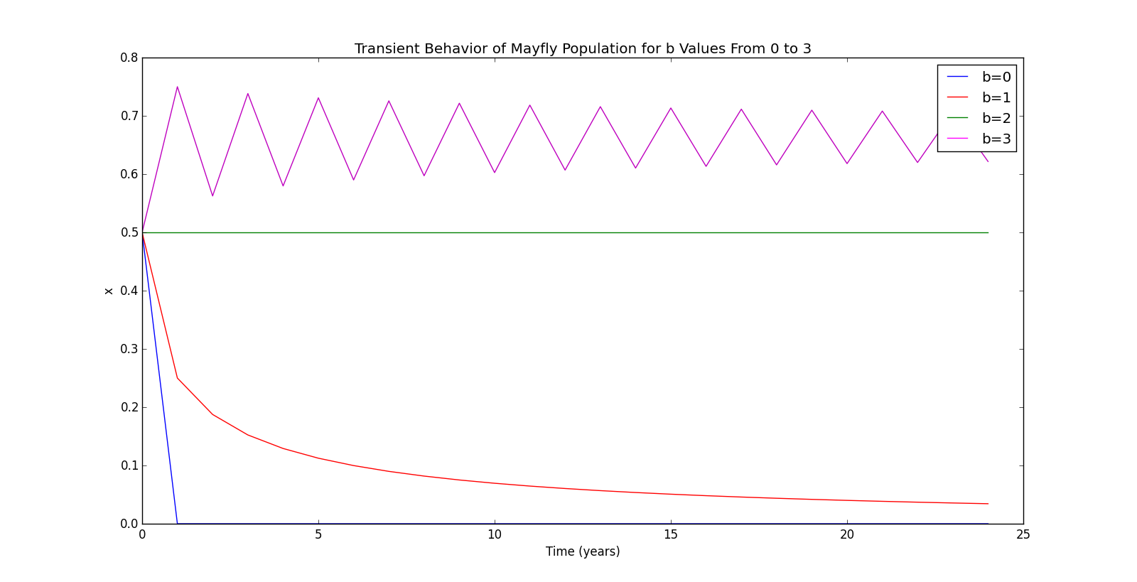Figure 1
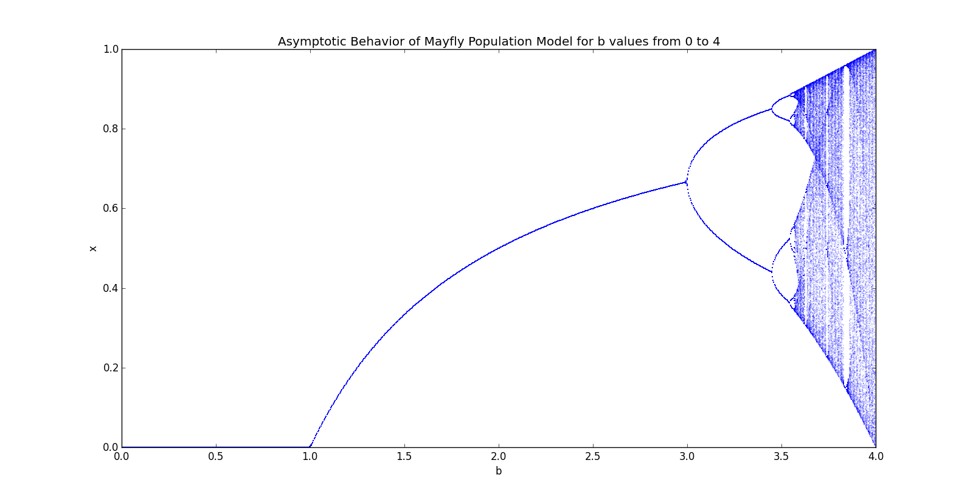Figure 2
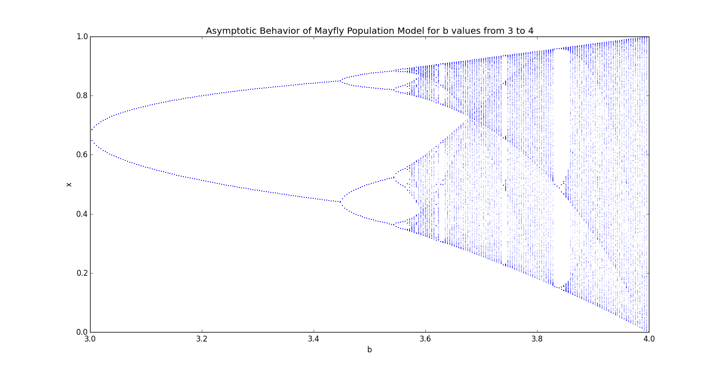Figure 3

Conclusion
In the transient response plot in figure 1, it can be seen that the mayfly population approaches 0 for 'b' values of 0 and 1. When b=2, the population appears to stabilize at the initial population (x₀=0.5 in this case). By also examining figure 2, it is apparent that the population only stabilizes at an 'x' value greater than 0 when 'b' is greater than 1. This means that female mayflies must produce more then two offspring each year in order to sustain the population. This is reasonable given that the model assumes an exact 50/50 male/female ratio, that it takes 1 male and 1 female to produce offspring, and that mayflies can only breed once. The reason that the population doesn't remain at its initial level when b=1 is due to the fact that the model was derived with the assumption that population growth drops as population increases, meaning that the “effective” population growth is much lower. From figures 1 and 2, it can also be seen that oscillatory behavior begins when b=3. This is most likely the result of the population “overshooting” the stable point when the population is low and then significantly decreasing because the population is too high every two years. The oscillations occur because the population reacts too quickly to population changes due to the large growth rate. This oscillatory behavior exhibits some very strange behavior when b is larger than 3, and can be seen more clearly in figure 3.
When b is between 3 and 4, the model begins to act very differently than it did for b values from 1 to 3. There are 2 points that appear opaque for each b value after 3 because the population oscillates between 2 values as time approaches infinity rather than approaching and stabilizing at one. Interestingly, after the first fork in the plot, there are two more that very closely resemble the first, each with their own fork. The plot appears to have a pattern that continuously repeats as b increases. Each fork has two more forks that have two more forks, and each fork is shaped exactly the same, but scaled down. This behavior is seen in fractals, or “infinitely complex patterns that are self-similar across different scales”[1]. Unfortunately, further mathematical analysis of the exact nature and shape of this fractal is beyond the scope of this assignment.
Python Code
#William Mackay
#MTH 337 Assignment 3- Mayfly Population Model Analysis

from pylab import *

#Plotting transient behavior for different values of b
def mayfly_population(x_0,b,t,plot_string):
x=[0]*(t)
x[0]=x_0
for i in xrange(1,t):
x[i]=b*(1-x[i-1])*x[i-1]
plot(range(t),x,plot_string)

t=25
x_0=0.5
b_transient=linspace(0,3,4)
color=['b','r','g','m']

figure(1)
for j in xrange(4):
mayfly_population(x_0,b_transient[j],t,color[j])

xlabel('Time (years)')
ylabel('x')
title('Transient Behavior of Mayfly Population for b Values From 0 to 3')
legend1 = Line2D([], [], color='blue', label='b=0')
legend2 = Line2D([], [], color='red', label='b=1')
legend3 = Line2D([], [], color='green', label='b=2')
legend4 = Line2D([], [], color='magenta', label='b=3')
legend(handles=[legend1,legend2,legend3,legend4])

#Plotting asymptotic region of model for each b value
b=linspace(0,4,1000)
x=0.5
t_max=750
t_min=t_max/2

for i in xrange(t_max):
if i>t_min:

figure(2)
plot(b,x,'b.',ms=1,alpha=.3)
xlabel('b')
ylabel('x')
title('Asymptotic Behavior of Mayfly Population Model for b values from 0 to 4')

figure(3)
plot(b,x,'b.',ms=1,alpha=.3)
xlim((3,4))
xlabel('b')
ylabel('x')
title('Asymptotic Behavior of Mayfly Population Model for b values from 3 to 4')

#Population Model
x=b*(1-x)*x

show()

